Ethical Enquiry Form: LC/worked example

Applicant name: Leslie Crombie

- Please describe your research question (or focus of your research):

How can we co-create (with design leadership students) a learning approach to the development of visual strategies?

The aim of this enquiry is to begin to understand how generative AI can be used to help students learn to develop effective visual strategies. It is also intended to begin to integrate the potential of AI into their practises. To embrace the potential of AI as a design tool, and to recognise and avoid the potential of homogenisation of design strategy through use of AI.

- Who will be providing you with information to help you answer your question?
A brief discovery will include expert interviews with a couple of London agencies leaders/practitioners. The 2023-24 cohort of the MADM (29 students) will participate in a working session as part of the curriculum. Prior, they will be contacted via their email addresses with information about the study and a link and/or return slip to inform the researcher that they agree to be included in the work session. For those people who fail to return the form, an online form will be shared on the day of the session (December 4, 2023). All respondents will be contacted via email the following week to gather their post session reflections. Students will be given the option to opt out at any time, and simply participate in the learning experience, which takes priority over the research. However, as this work session is part of the research unit, it is expected that the transparency of the research process and consent will provide a real-life research experience that students can use in their own course research requirements.

Sam Barber will be a co-leader of the working session and will be asked for her reflections as well.
What will you be asking participants to do?

The conversation with expert interviewees will explore how they are currently using image generating AI (and which tool), as well as the advantages and watch-outs for its use..

Students will be asked to participate in the working session:
- as co-creators of the working session process
- as participants in a visual strategy development workshop
- on the day and in a post session email for their reflections: what worked, what was missing, what could be done differently for the next session
Details:
1. The working session will be part of the Research Unit as their lecture on visual strategy and will include a brief description of the relationship between visual and verbal strategy.
- A proposed approach to the work-session flow
- A discussion regarding their edits/builds/familiarity with generative Ai/imagery
- The working session will be conducted in teams of ?? and will use their current stage of strategy for their FMP’s as they have been working on this for 2 months
- They will then be asked: what worked/how do you feel about the session/what did you learn about visual strategy? How effective was the use of AI in their development of AI, how well did it work: what was good, bad, missing/can they use if in their practice? How could we have improved the session?
- A follow up email will be sent requesting their reflections after one week.

The observations of both the tutors and the students’ will be synthesised and analysed for themes, focusing primarily on factors that have enabled and/or hindered engagement with both the development of teaching practice. The analysis will be resent to the students for their comment and further inputs. All responses, whether live or via email, will be anonymous.

- How will you get informed consent from these participants?

An information and consent sheet will be sent out by email to all potential participants, with the opportunity to opt out before the working session takes place. A consent form will be also be available at the start of the working session for those who haven’t yet submitted their form prior to the session. As all participation will be anonymous, it will not be possible to withdraw their consent retrospectively.

In the second follow up email, informed consent will be assumed when a participant provides a response to the 2nd opportunity to provide reflection, and their respo9nse to the analysis. As questionnaire responses are anonymous, it will not be possible for participants to withdraw their consent retrospectively.

- What potential risks to the interests of participants do you foresee and what steps will you take to minimise those risks? A participant’s interests include their physical and psychological wellbeing; their commercial interests; and their rights of privacy and reputation.
Deductive Disclosure
While participants will be assured of confidentiality and personal identifiers will be removed from transcripts, rich descriptions of personal circumstances in the data present a risk of deductive disclosure. There is a conflict between conveying detailed, accurate accounts of the social world and protecting the identities of the individuals who participated in the research (Weiss 1994).

Kaiser (2009) argues for addressing deductive disclosure through considerations of the audience of one’s research and a re-envisioned informed consent process. Weiss (1994) alters non-essential information, such as a respondent’s specific occupation or the number of children she has to render her unrecognizable to others. Hopkins (1993) creates entirely new “characters” and scenes that are a composite of many people and events she witnessed in her fieldwork but which represent no single person.

In this study, the risk of deductive disclosure will be addressed as follows:
1) The participant information sheet will clearly set out the intended audience for the study, which is the Academic Practice programmes team and senior management at the university.

2) Where appropriate, non-essential information will be altered to ensure participants are not recognisable

3) The primary outcome from the study will be a synthesised observation/feedback of what worked and what could be improved from both the student participants and from the peer co-lecturer. The students’ feedback will be completely anonymous. While this may include quotations and anecdotes from individuals, the necessarily concise nature of this report and its focus on generating general recommendations will mean that rich descriptions of experience will be partial and decontextualised.

Validity of informed consent
This is not only ‘insider’ research, but also pedagogic research, and as such it blurs the boundaries between teacher and researcher, and student/colleague and research participant. Researching one’s own students and/or colleagues can raise issues of the validity of informed consent. The following steps will be taken to ensure that participation is voluntary and non-participation is not penalised, directly or indirectly:

Students' educational needs will be placed above the goals of the project. It is likely that participants will benefit educationally from co-creation of the lecture/session.

Participants may perceive pressure to remain opted in to the study, as the research design requires that students will need to explicitly opt out if they do not wish to participate. The above offer should go some way to addressing this concern, as it demonstrates an explicit desire on our part that those opting out are not penalised. I have chosen a default opt-in mode as it is important for the validity of the findings that the sample is random. This sampling method will demand more clear communication in the recruitment stage, but it is anticipated that participants will appreciate the learning opportunity.

Risk of participant distress
It is not likely that participants will experience personal distress, rather, empowerment as co-researchers and co-creators of their learning journey.

- What potential risks to yourself as the practitioner do you foresee and what steps will you take to minimise those risks?

I do not forsee any potential risks to myself as the researcher.

- Does your project involve children or vulnerable adults e.g. a person with a learning disability?

Delete as appropriate: NO

If yes, please describe what extra measures you will put in place regarding safeguarding:

- How will you store the information you gather from participants?

The email responses will be retained on a secure server, so that the data can be made available for future research. All information pertaining to the identities of the participants, including all correspondence between myself and the interview subjects, will be deleted.

I confirm my responsibility to deliver the project in accordance with the Code of Practice on Research Ethics of the University of the Arts London (the University). In signing this form I am also confirming that:

- The form is accurate to the best of my knowledge and belief.
- I understand and accept that the ethical propriety of this project may be monitored by the relevant College Research body and/or the University’s Research Ethics Sub-Committee.
Signed: 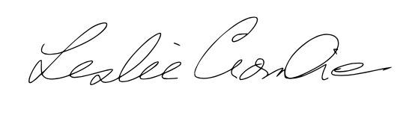 Date: 27.10.23
I support this project and have reviewed it with the participant:
Signed: 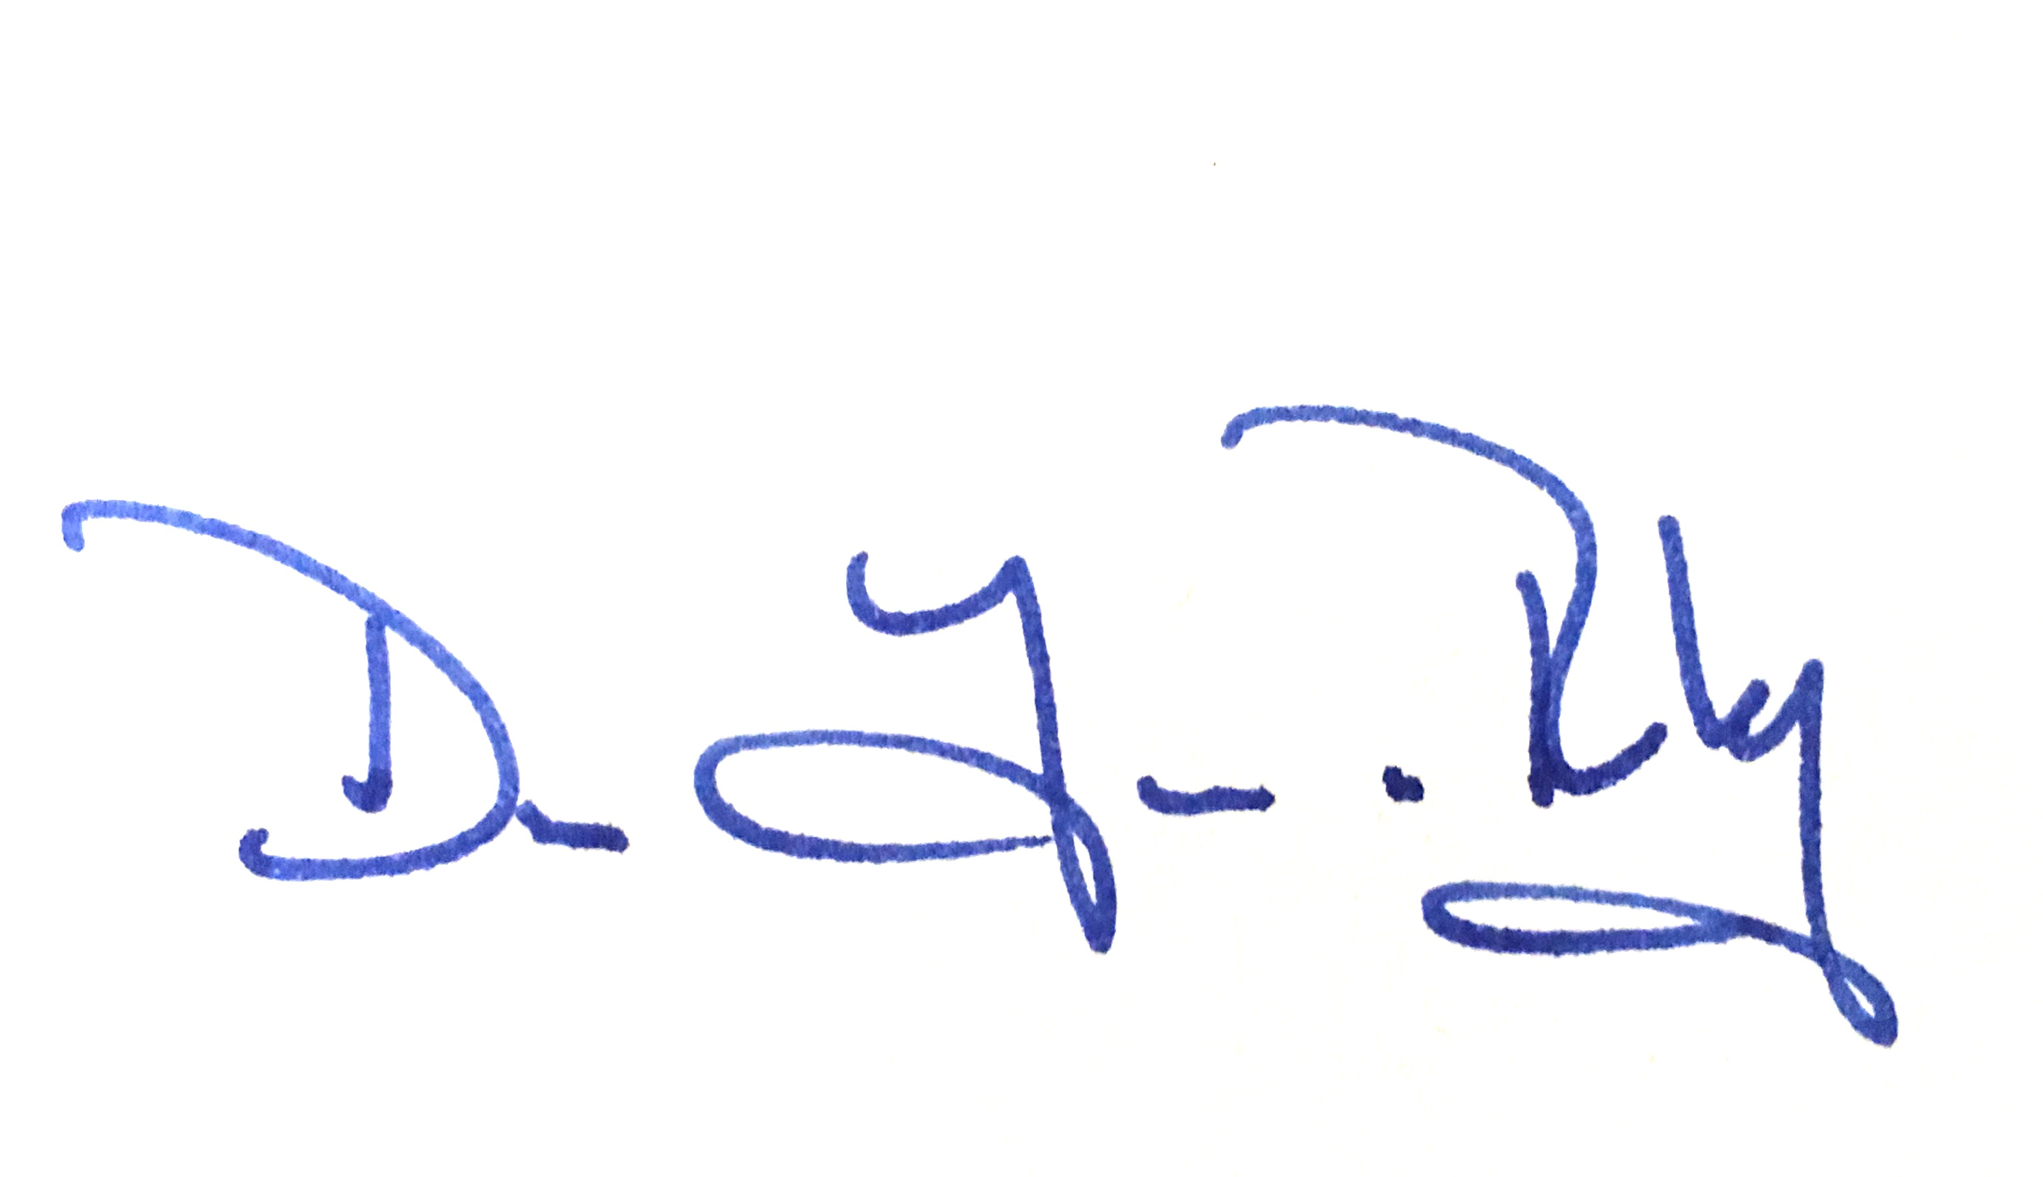 Date: 27.10.23

